* **For Data Analysis using DAX Functions:**

1.Create a new table that consolidates information from multiple tables using DAX

Answer- For this I have created a new tablename Summary_Consolidatetable then apply summarise formula

Summary_Consolidatetable = SUMMARIZE('Health Expenditure', Country[CountryName], Year[Year], "TotalhealthExpenditure",sum('Health Expenditure'[ExpenditureAmount]),"Total_GDP",SUM(GDP[GDPAmount]),"Total_population",sum(Population[PopulationCount]))

2. Find the countries/regions with the highest and lowest health expenditure for all years.

Answer- For this I have created two multi row cards and select country and health expenditure and apply filter on the country for top 1 and bottom 1 for highest and lowest expenditure

Highest_expenditure = calculate(max('Summary_Consolidatetable'[TotalhealthExpenditure]))

Lowest_expenditure = calculate(MIN('Summary_Consolidatetable',[TotalhealthExpenditure]))

3.Determine the percentage of health expenditure as a share of GDP for each country

Answer- For this I have created table name summarise country

summarise_country = SUMMARIZE(Summary_Consolidatetable, Summary_Consolidatetable[CountryName],"Total_health_Exp",sum(Summary_Consolidatetable[TotalhealthExpenditure]),"Total_GDP", sum(Summary_Consolidatetable[Total_GDP]))

4. Calculate the average health expenditure per capita for each country/region.

Answer – For this I have created a new table name AVG_HealthExp_per_capita

AVG_HealthExp_per_capita = SUMMARIZE(Summary_Consolidatetable, Summary_Consolidatetable[CountryName],"Total_healthExp", AVERAGE(Summary_Consolidatetable[TotalhealthExpenditure]),"Total_Population", AVERAGE(Summary_Consolidatetable[Total_population]))

For Visualisation-

1.Calculate the year-to-year percentage change in health expenditure.

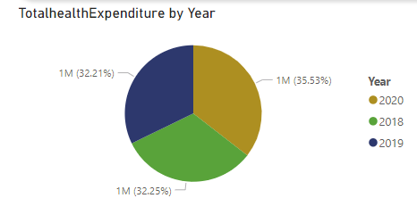

Hear I use pie chart because it will be best for providing information and I put Sum of Total health expenditure in values section and Years in legend as it

2. Calculate the average annual growth rate of health expenditure over a selected period.

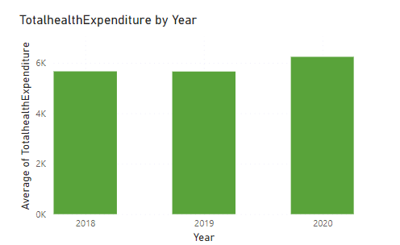

Here I use clusted column chart as it give annually wise Health Expenditure. And for clusted column chart I put years in X axis and and average health expenditure in y axis.

3.Create a line chart to visualise the trend of health expenditure over the years for selected countries/regions.

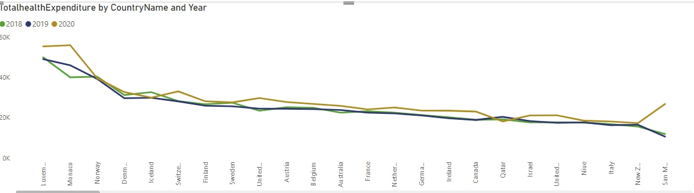

For line chart in visual panel I put country name in x axis and Total health Expenditure in y axis and year in legend part.

4. Create a bar chart to compare health expenditure across different countries/regions for a 2020 year.

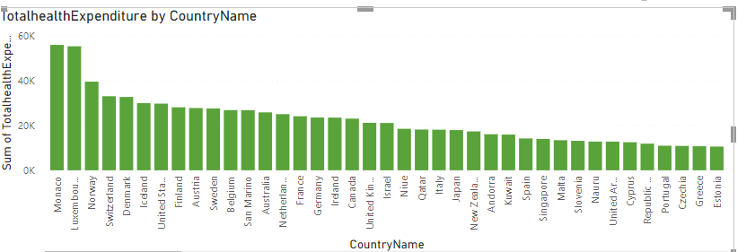

In visual panel for bar chart I put country name in X axis and Total health expenditure in Y axis and I put country in filter in filter panel and select basic filtering option and select 2020 year.

5. Use a scatter plot to explore the relationship between health expenditure and GDP.

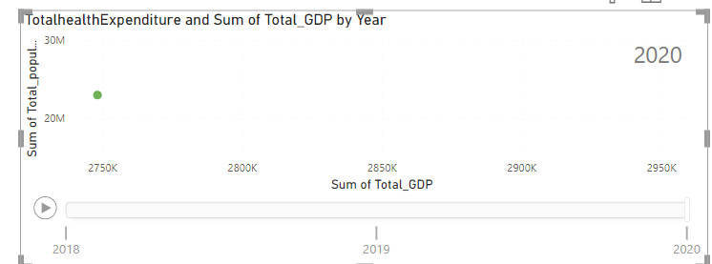

Hear I put Total GDP in X axis and total Health expenditure in Yaxis and put year in play axis

6.Utilise a map visualisation to show health expenditure distribution geographically.

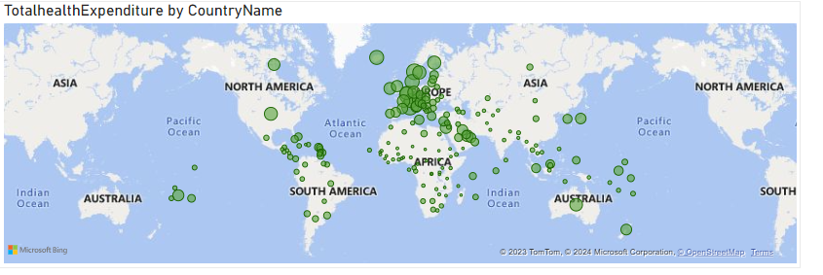

I put country name in location in visualization panel and total health expenditure in bubble section. Here bubble size represent maximum of health expenditure of countty